SESSION 4 – LAB EXPERIMENTS
Ch. Bhargav Ram
192425334
Exp 1:
Input: s = &quot;abbxxxxzzy&quot;
Output: [[3,6]]
Explanation: &quot;xxxx&quot; is the only large group with start index 3 and end index 6.
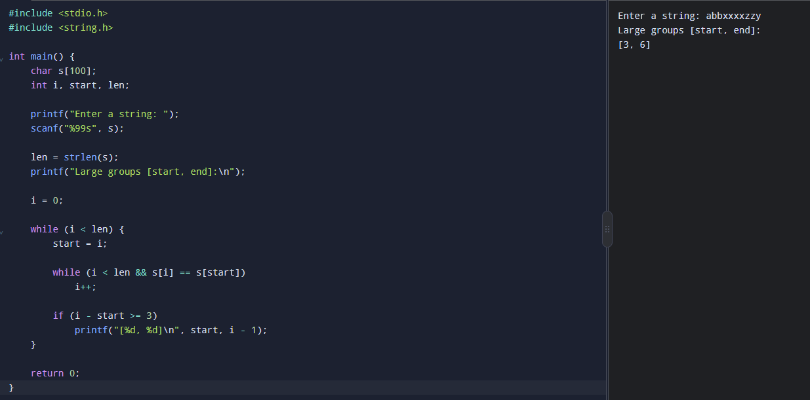

Exp 2:

Input: board = [[0,1,0],[0,0,1],[1,1,1],[0,0,0]]
Output: [[0,0,0],[1,0,1],[0,1,1],[0,1,0]]
Code: #include <stdio.h>
#include <stdlib.h>

void gameOfLife(int board[100][100], int m, int n) {
int directions[8][2] = {
{-1, -1}, {-1, 0}, {-1, 1},
{0, -1}, {0, 1},
{1, -1}, {1, 0}, {1, 1}
};
int i, j, k, x, y, live;
for (i = 0; i < m; i++) {
for (j = 0; j < n; j++) {
live = 0;
for (k = 0; k < 8; k++) {
x = i + directions[k][0];
y = j + directions[k][1];
if (x >= 0 && x < m && y >= 0 && y < n &&
abs(board[x][y]) == 1) {
live++;
}
}
if (board[i][j] == 1 && (live < 2 || live > 3)) {
board[i][j] = -1;
} else if (board[i][j] == 0 && live == 3) {
board[i][j] = 2;
}
}
}

for (i = 0; i < m; i++) {
for (j = 0; j < n; j++) {
if (board[i][j] == -1)
board[i][j] = 0;
else if (board[i][j] == 2)
board[i][j] = 1;
}
}
}

int main() {
int board[100][100];
int m, n, i, j;

scanf("%d %d", &m, &n);

for (i = 0; i < m; i++) {
for (j = 0; j < n; j++) {
scanf("%d", &board[i][j]);
}
}

gameOfLife(board, m, n);

for (i = 0; i < m; i++) {
for (j = 0; j < n; j++) {
printf("%d", board[i][j]);
if (j < n - 1)
printf(" ");
}
printf("\n");
}

return 0;
}
Output:
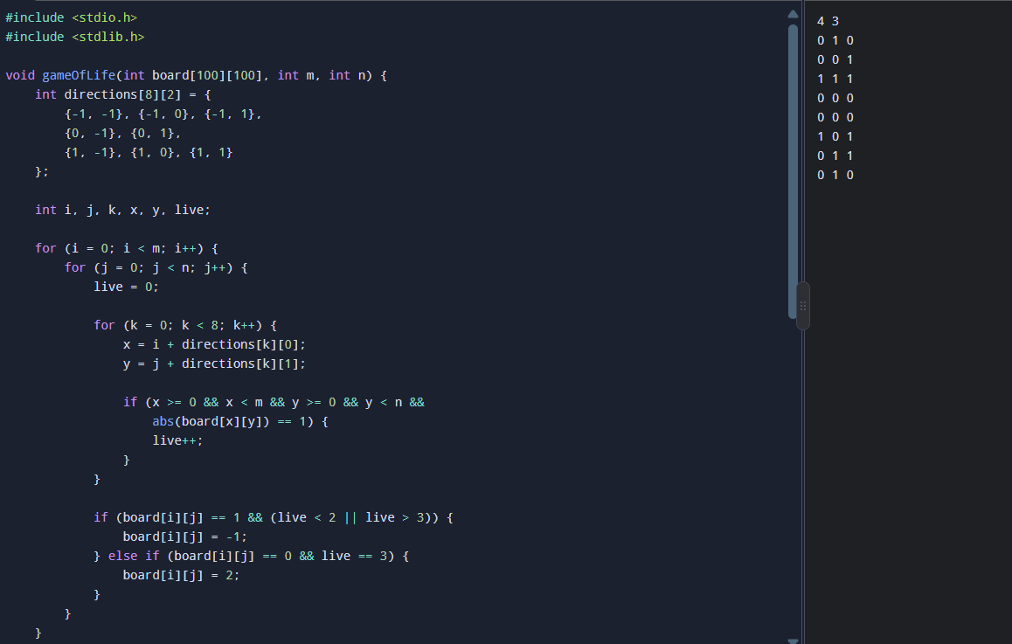
Exp – 3:
Code: Output
